April 2024

STRATEGIC ENVIRONMENTAL ASSESSMENT & HABITATS REGULATIONS ASSESSMENT: SCREENING REPORT

Little Woodhouse Draft Neighbourhood Plan



Contents

Contents
STRATEGIC ENVIRONMENTAL ASSESSMENT & HABITATS REGULATIONS ASSESSMENT: SCREENING REPORT 0
Little Woodhouse Draft Neighbourhood Plan 0
Contents 1
1. Introduction 2
2. Legislative background 4
3. Little Woodhouse Draft Neighbourhood Plan Overview 6
4. Summary of Comments – Statutory Consultation Bodies 7
5. SEA Screening Assessment 8
Table 1 – Application of the SEA Directive 9
Table 2 – Assessment of likely significant effects 11
Consideration of Little Woodhouse draft Policies 12
SEA Screening Conclusions 14
6. HRA Screening 15
HRA Screening Conclusions 16
7. Screening Conclusions 17
APPENDIX 1 18
Responses from Environmental Assessment Consultation Bodies 18
APPENDIX 2 18
Map showing SPAs and SACs in relation to the Little Woodhouse Neighbourhood Area 18

1. Introduction

  - The purpose of this report is to determine whether the draft Little Woodhouse Neighbourhood Plan (LWNP) requires a Strategic Environmental Assessment (SEA) and/or a Habitats Regulations Assessment (HRA) through a process referred to as SEA and HRA screening.

  - A Strategic Environmental Assessment is a process for evaluating, at the earliest appropriate stage, the environmental effects of a plan before it is given effect. The SEA screening determines whether the plan is likely to have significant environmental effects. If likely significant environmental effects are identified, an environmental report must be produced.

  - A Habitats Regulations Assessment identifies whether a plan is likely to have a significant effect on a European site, either alone or in combination with other plans or projects. A HRA is required when it is deemed that likely significant effects may occur on protected European Sites (Natura 2000 sites) as a result of the implementation of a plan/project. The HRA screening will determine whether significant effects on a European site are likely.

  - This report explains the legislative background to SEA and HRA screening, provides details of the draft LWNP before undertaking a SEA and HRA screening exercise and providing conclusions.

  - Leeds City Council has prepared this screening report on behalf of Little Woodhouse Neighbourhood Forum, the qualifying body for the Little Woodhouse Neighbourhood Plan, as part of the neighbourhood planning duty to support. Leeds City Council has a responsibility to advise the Forum if there is a need for formal SEA or HRA of the draft plan. Two of the ‘basic conditions’ against which the neighbourhood plan will be tested by the independent examiner are:
- Whether the making of the neighbourhood plan is compatible with European Union obligations (this includes the SEA Directive)
- Whether the making of the neighbourhood plan will breach the requirements of Chapter 8 of Part 6 of the Conservation of Habitats and Species Regulations (2017).

  - An SEA Screening Assessment was also undertaken in 2020 for a previous version of the Little Woodhouse Neighbourhood Plan, however it was considered that given the time that has elapsed, a new SEA/HRA Screening was appropriate.

  - For the purposes of this assessment, the latest version of the draft plan sent to Leeds City Council in May 2023 has been screened. This version of the plan is considered to show a firm vision and policy direction. As a consequence the neighbourhood plan is considered to be at an appropriate stage for the screening exercise to be undertaken.

2. Legislative background

Strategic Environmental Assessment (SEA)

2.1 The basis for Strategic Environmental Assessments and Sustainability Appraisal legislation is European Directive 2001/42/EC which was transposed into English law by the Environmental Assessment of Plans and Programmes Regulations 2004, or SEA Regulations. The 2008 Planning Act removed the requirement to undertake a Sustainability Appraisal of development plan documents (DPDs), including neighbourhood plans, however there is still a need for a Strategic Environmental Assessment.

2.2 Amendments to the Neighbourhood Plan Regulations in February 2015 introduced the requirement for an environmental report (prepared in accordance with the Environmental Assessment of Plans and Programmes Regulations 2004), or a statement of reasons why an environment assessment is not required, to be submitted to the Local Planning Authority. This is to inform the public and to ensure independent examiners have sufficient information to determine whether a neighbourhood plan is likely to have significant environmental effects.

2.3 Regulation 9 of the SEA Regulations 2004 advises that draft neighbourhood plan proposals should be screened (assessed) to determine whether the plan is likely to have significant environmental effects, taking into account the criteria specified in schedule 1 and comments from the environmental consultation bodies. A SEA may be required, for example, where the neighbourhood plan allocates sites for development, or the neighbourhood area contains sensitive natural or heritage assets that may be affected by proposals in the plan.

  - Where it is determined that the plan is unlikely to have significant environmental effects, and accordingly, does not require an environmental assessment, the authority is required to prepare a statement for its reasons for the determination. If likely significant environmental effects are identified, then an environmental report must be prepared in accordance with paragraphs (2) and (3) of regulation 12 of the SEA Regulations 2004.

Habitat Regulation Assessment (HRA)

  - Article 6 (3) of the EU Habitats Directive and Regulation 61 of the Conservation of Habitats and Species Regulations 2010 (as amended) require that an appropriate assessment of the implications of the plan or project for European sites is carried out with regard to the Conservation Objectives of European Sites and with reference to other plans and projects to identify if any significant effect is likely for any European Site. A screening is undertaken to determine whether the plan is likely to have a significant effect on a European site and, if so, an appropriate assessment of the implications must be undertaken against the site’s Conservation Objectives.

  - The judgement of the European Union Court of Justice in ‘People Over Wind’ dated 12 April 2018 has implications for the HRA screening process. The judgement considered whether it is possible to take account of “measures intended to avoid or reduce the harmful effects of the plan (or project) on the site” i.e. mitigation, at the screening stage. As the Directive is silent on “mitigation”, the Court found it is not possible to take mitigation into account at the screening stage.

  - This screening therefore assesses the risk that the LWNP will have a significant effect on a European site by considering the characteristics and specific environmental conditions of the site along with the proposals of the draft Plan; completed mitigation measures and other conservation, preventative and compensatory measures.

  - The ruling necessitated a change to the habitat conservation regulations (The Conservation of Habitats and Species and Planning (Various Amendments) (England and Wales) Regulations 2018) which amended the neighbourhood planning basic condition. Examiners must now consider whether “The making of the neighbourhood development plan does not breach the requirements of Chapter 8 of Part 6 of the Conservation of Habitats and Species Regulations 2017.”

  - On 25 July 2018, the Court of Justice (Second Chamber) ruled in the case of Grace, Sweetman and the National Planning Appeals Board Ireland (ECLI:EU:C2018:593). This Judgement relates to Appropriate Assessments and how conclusions should be interpreted which in turn determines whether Article 6(3) or Article 6(4) of the Directive applies. If a screening concludes an Appropriate Assessment is not required, this Judgement is not applicable.

3. Little Woodhouse Draft Neighbourhood Plan Overview

3.1 Whether a neighbourhood plan requires a SEA or HRA is dependent on what is being proposed within the plan. The LWNP contains a set of locally specific planning policies and guidance for the Neighbourhood Area.

3.2 The vision of the draft plan is

Little Woodhouse will be a strong and resilient mixed and balanced community of long-term residents, families, students and young professionals, with good connections to the nearby city centre, the universities, the LGI hospital and major transport links. There will be strong community links across different groups and organisations involved in the area. The Little Woodhouse area will retain and respect its rich heritage of buildings, streets and green spaces and will provide an attractive environment to residents and visitors, resilient to climate change. There will be clean and tidy streets with improvements in the environment, including litter collection, parking arrangements and safe bus, cycling and pedestrian routes. The area will offer sustainable places to live to different sized households and different age groups with opportunities to work, study, shop, and to enjoy leisure and healthy exercise close by. There will be good access to health and education services for all age groups. It will be a tranquil area with a low crime rate for an inner-city area.

3.3 Overall the LWNP also seeks to retain and protect the existing features and character of the area, to improve services and access and to provide housing to meet local need. The neighbourhood plan includes draft policies focused on the following issues:

- Protection of the local historic and architectural character, including non-designated heritage assets.
- Protection of local green spaces
- High quality design
- Protection of the rural landscape setting and views
- Protection of trees
- Protection of community facilities
- Provision of a mix of housing types, including those for first time buyers and older people
- Erection of telecommunications equipment or small-scale low-carbon energy production equipment

3.4 Once made, the Neighbourhood Plan will become part of the Leeds Development Plan and the policies within the plan will be used, alongside other adopted Development Plan documents in the determination of planning applications within the Little Woodhouse Neighbourhood Area.

4. Summary of Comments – Statutory Consultation Bodies

4.1 It is a requirement of the SEA and HRA screening process to consult the environmental assessment consultation bodies when forming a view on whether a SEA is required. Regulation 4 of the Environmental Assessment of Plans and Programmes Regulations 2004 defines these consultation bodies as Historic England, the Environment Agency and Natural England.

4.2 A copy of the draft LWNP was initially sent to the environmental assessment consultation bodies in June 2018. All of the consultation bodies provided comments to the consultation at that time. An advanced draft was sent to the consultation bodies in July 2023 and Natural England and Historic England responded.

  - Full details of the responses can be found in Appendix 1 of this report. A summary of their responses is provided within the table below:
Consultation Body | Summary of comments
Historic England | The Draft Neighbourhood Development Plan indicates that within the plan area there are a number of designated cultural heritage assets, including 2 Grade II* and 38 grade II listed buildings and 3 Conservation Areas. There are also likely to be other features of local historic, architectural or archaeological value, and consideration should also be given to the wider historic landscape.  On the basis of the information supplied, and in the context of the criteria set out in Schedule 1 of the Environmental Assessment Regulations [Annex II of ‘SEA’ Directive], Historic England concurs with the conclusion of the Strategic Environmental Assessment & Habitats  Regulations Assessment: Screening Report Little Woodhouse Draft Neighbourhood Plan (July 2023), para. 5.11, that the preparation of a Strategic Environmental Assessment is not required.  The views of the other three statutory consultation bodies should be taken into account before the overall decision on the need for an SEA is made.  We should like to stress that this opinion is based on the information available in the Draft Policy Intentions Document for the Little Woodhouse Neighbourhood Plan. To avoid any doubt, this does not reflect our obligation to provide further advice on later stages of the SEA process and, potentially, object to specific proposals which may subsequently arise (either as a result of this consultation or in later versions of the plan/guidance) where we consider that, despite the SEA, these would have an adverse effect upon the environment.  We would be pleased if you can send a copy of the determination as required by REG 11 of the  Environmental Assessment of Plans and Programmes Regulations 2004.  Historic England strongly advises that the conservation and archaeological staff of the Leeds City Council and the West Yorkshire Archaeological Advisory Service are closely involved throughout the preparation of the plan and its assessment. They are best placed to advise on; local historic environment issues and priorities, including access to data held in the HER (formerly SMR); how the policy or proposal can be tailored to minimise potential adverse  impacts on the historic environment; the nature and design of any required mitigation measures; and opportunities for securing wider benefits for the future conservation and  management of historic assets.
Environment Agency | No Response
Natural England | Screening Request: Strategic Environmental Assessment (SEA) and Habitats Regulations Assessment (HRA)  It is Natural England’s advice, on the basis of the material supplied with the consultation, that:  • significant effects on statutorily designated nature conservation sites or landscapes are unlikely; and,  • significant effects on Habitats sites1, either alone or in combination, are unlikely.  The proposed neighbourhood plan is unlikely to significantly affect any Site of Special Scientific Interest (SSSI), Marine Conservation Zone (MCZ), Special Areas of Conservation (SAC), Special Protection areas (SPA), Ramsar wetland or sites in the process of becoming SACs or SPAs (‘candidate SACs’, ‘possible SACs’, ‘potential SPAs’) or a Ramsar wetland. The plan area is unlikely to have a significant effect on a National Park, Area of Outstanding Natural Beauty or Heritage Coast, and is unlikely to impact upon the purposes for which these areas are designated or defined.  Guidance on the assessment of Neighbourhood Plans, in line with the Environmental Assessment of Plans and Programmes Regulations 2004 is contained within the Planning Practice Guidance. This identifies three triggers that may require the production of an SEA:  • a neighbourhood plan allocates sites for development  • the neighbourhood area contains sensitive natural or heritage assets that may be affected by the proposals in the plan  • the neighbourhood plan may have significant environmental effects that have not already been considered and dealt with through a sustainability appraisal of the Local Plan.  Natural England does not hold information on the location of significant populations of protected species, so is unable to advise whether this plan is likely to affect protected species to such an extent as to require an SEA. Further information is included in Natural England’s standing advice on protected species.  Furthermore, Natural England does not routinely maintain locally specific data on all environmental assets. The plan may have environmental impacts on priority species and/or habitats, local wildlife sites, soils and best and most versatile agricultural land, or on local landscape character that may be sufficient to warrant an SEA. Information on ancient woodland, ancient and veteran trees is set out in Natural England/Forestry Commission standing advice.  We therefore recommend that advice is sought from your ecological, landscape and soils advisers, local record centre, recording society or wildlife body on the local soils, best and most versatile agricultural land, landscape, geodiversity and biodiversity receptors that may be affected by the plan before determining whether a SEA is necessary.

5. SEA Screening Assessment

5.1 The flowchart below illustrates the process for screening a planning document to ascertain whether a full SEA is required:

FIGURE 1: APPLICATION OF THE SEA DIRECTIVE TO PLANS AND PROGRAMMES

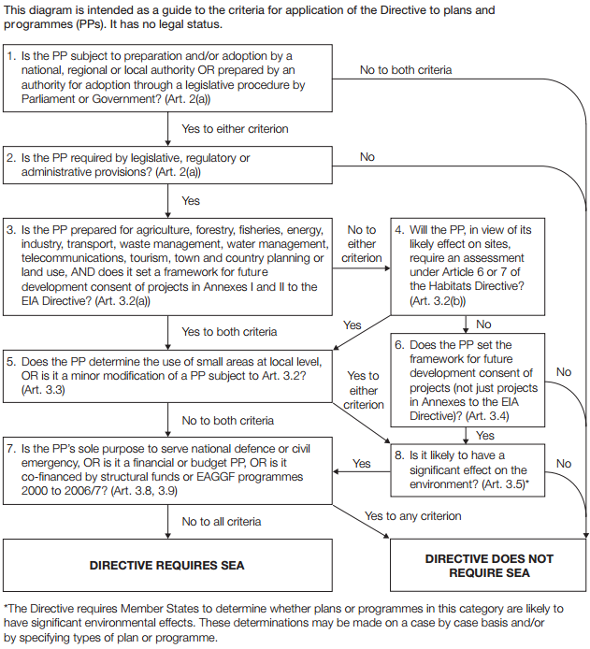

5.2 Table 1 helps to apply the Directive by running the draft plan through the questions outlined within Figure 1:

Table 1 – Application of the SEA Directive

Stage | Y/N | Reason
1. Is the PP (plan or programme) subject to preparation and/or adoption by a national, regional or local authority OR prepared by an authority for adoption through a legislative procedure by Parliament or Government? (Art. 2(a)) | Y | Neighbourhood Plans are prepared by a ‘qualifying body’ (Parish/Town Council or designated Neighbourhood Forum) under the provisions of the Town and Country Planning Act 1990 as amended by the Localism Act 2011. A neighbourhood plan is subject to an examination and referendum. If it receives 50% or more ‘yes’ votes at referendum, it will be ‘made’ by Leeds City Council as the Local Planning Authority.
2. Is the PP required by legislative, regulatory or administrative provisions? (Art. 2(a)) | N | Communities have a right to be able to produce a neighbourhood plan, however communities are not required by legislative, regulatory or administrative purposes to produce a neighbourhood plan. This plan however if made would form part of the statutory development plan, therefore it is considered necessary to answer the following questions to determine further if an SEA is required.
3. Is the PP prepared for agriculture, forestry, fisheries, energy, industry, transport, waste management, water management, telecommunications, tourism, town and country planning or land use, AND does it set a framework for future development consent of projects in Annexes I and II to the EIA Directive? (Art 3.2(a)) | N | The draft plan is being prepared for town and country planning and land use and once adopted and will be part of the planning policy framework determining future development within the Little Woodhouse Neighbourhood Area. Developments that fall within Annex I are ‘excluded’ development for Neighbourhood Plans (as set out in Section 61(k) of the Town and Country Planning Act 1990 (as amended). It is not anticipated that the Little Woodhouse Neighbourhood Plan would be the tool to manage development of the scale and nature envisaged by Annex I and Annex II of the EIA Directive.
4. Will the PP, in view of its likely effect on sites, require an assessment for future development under Article 6 or 7 of the Habitats Directive? (Art. 3.2 (b)) | N | See screening assessment for HRA in Section 6 of this report.
5. Does the PP Determine the use of small areas at local level, OR is it a minor modification of a PP subject to Art. 3.2? (Art. 3.3) | Y | Once made the LWNP will be part of the land use framework for the area and will help to determine the use of small areas at a local level. The LWNP seeks to designate several areas as Local Green Spaces.  GO TO STEP 8
6. Does the PP set the framework for future development consent of projects (not just projects in annexes to the EIA Directive)? (Art 3.4) | Y | The LWNP will provide a framework for future development consent of projects in the area.  GO TO STEP 8
7. Is the PP’s sole purpose to serve the national defence or civil emergency, OR is it a financial or budget PP, OR is it co-financed by structural funds or EAGGF programmes 2000 to 2006/7? (Art 3.8, 3.9) | N/A | N/A
8. Is it likely to have a significant effect on the environment? Art. 3(5) | N | See section below.

5.3 The criteria for determining the likely significance of effects referred to in Article 3(5) of Directive 2001/42/EC are set out below in Figure 2.

FIGURE 2: CRITERIA FOR DETERMINING LIKELY SIGNIFICANT EFFECTS

1. The characteristics of plans and programmes, having regard, in particular, to

- the degree to which the plan or programme sets a framework for projects and other activities, either with regard to the location, nature, size and operating conditions or by allocating resources,
- the degree to which the plan or programme influences other plans and programmes including those in a hierarchy,
- the relevance of the plan or programme for the integration of environmental considerations in particular with a view to promoting sustainable development,
- environmental problems relevant to the plan or programme,
- the relevance of the plan or programme for the implementation of Community legislation on the environment (e.g. plans and programmes linked to waste management or water protection).

2. Characteristics of the effects and of the area likely to be affected, having regard, in particular, to

- the probability, duration, frequency and reversibility of the effects,
- the cumulative nature of the effects,
- the transboundary nature of the effects,
- the risks to human health or the environment (e.g. due to accidents),
- the magnitude and spatial extent of the effects (geographical area and size of the population likely to be affected),
- the value and vulnerability of the area likely to be affected due to:
  - special natural characteristics or cultural heritage,
  - exceeded environmental quality standards or limit values,
  - intensive land-use,
- the effects on areas or landscapes which have a recognised national, Community or international protection status.

5.4 An assessment of the likely significant effects resulting from the Neighbourhood Plan has been carried out in Table 2:

Table 2 – Assessment of likely significant effects

Criteria | Comments
1. The characteristics of plans and programmes, having regard, in particular, to
The degree to which the NP sets a framework for projects and other activities, either with regard to the location, nature, size and operating conditions or by allocating resources | The NP will set a policy framework for the determination of planning applications for future development projects. Once made the NP will form part of the Leeds Development Plan.
The degree to which the NP influences other plans and programmes including those in a hierarchy | The NP must be in general conformity with the strategic Leeds Local Plan and national planning policy. It does not influence other plans.
The relevance of the NP for the integration of environmental considerations in particular with a view to promoting sustainable development | The achievement of sustainable development is one of the basic conditions that the NP must meet. The draft plan includes themes and policies regarding the environment and sustainability and overall it aims to create sustainable communities.
Environmental problems relevant to the NP | It is not considered that there are any particular environmental problems relevant to the plan.
The relevance of the NP for the implementation of Community legislation on the environment (e.g. plans and programmes linked to waste management or water protection) | This criterion is unlikely to be directly relevant in regard to the NP.
2. Characteristics of the effects and of the area likely to be affected, having regard, in particular, to
The probability, duration, frequency and reversibility of the effects | Although no specific developments are proposed within the LWNP the document supports development and provides a framework for guiding any such development. It is likely that some development will occur during the duration of the Plan Period within the area therefore an element of environmental change will take place. However, the policies are designed to encourage new development that is sustainable and has the least negative and greatest positive environmental impacts.
The cumulative nature of the effects | The cumulative effects of proposals within the LWNP are unlikely to be significant on the local environment. The effects of the NP need to be considered alongside the Leeds Core Strategy, Site Allocations Plan and the Natural Resources and Waste DPD. The NP is required to be in general conformity with the Leeds Local Plan. It is not considered that the LWNP introduces significant additional effects over and above those already considered in the SA/SEA for the Core Strategy, SAP and NRWDPD. Notably it does not propose more development than the Core Strategy and SAP for the area.
The transboundary nature of the effects | The proposals within the LWNP are unlikely to have a significant impact beyond the Neighbourhood Area boundary. The policies within the draft Plan can only apply within the designated Little Woodhouse Neighbourhood Area.
The risks to human health or the environment (e.g. due to accidents) | None identified.
The magnitude and spatial extent of the effects (geographical area and size of the population likely to be affected), | The NP is concerned with development within the Little Woodhouse Neighbourhood Area. The potential for environmental impacts are likely to be local, limited and minimal.
The value and vulnerability of the area likely to be affected due to:  - special natural characteristics or cultural heritage,  - exceeded environmental quality standards or limit values,  - intensive land-use, | The LWNP is unlikely to adversely affect the value and vulnerability of the area in relation to its special natural characteristics or cultural heritage. The policies within the plan seek to provide greater protection to the character of the area. It does not allocate any sites, as such there are unlikely to be any intensive land-use concerns.
The effects on areas or landscapes which have a recognised national, Community or international protection status. | It is not considered that the draft policies in the LWNP will adversely affect areas or landscapes which have a recognised national, community or international protection status. The policies do not allocate land for development and the document also seeks to protect some local green spaces.

Consideration of Little Woodhouse draft Policies

Housing

5.5 Policies H1 – H6: The Plan seeks to readdress the mix of housing particularly where there is a high level of student accommodation and houses in multiple occupation (HMO) and makes provision for more family accommodation and less purpose built student accommodation (PBSA) and HMOs (Policy H1). It encourages the provision of family dwellings in new development (Policy H2) as well as the avoidance of high concentration and poor quality of PBSA (Policy H3). Conversion to student accommodation should be designed to facilitate future conversion to a residential use (Policy H4) and should be located in an identified area. There is a presumption against HMO development unless excessive concentrations can be avoided (Policy H5). . Onsite provision of affordable housing is encouraged (Policy H6) Whilst development will inevitably have an environmental effect, the conversion of buildings will help to minimise new construction. The Plan does not allocate any sites for development.

Heritage and Character

5.6 Policies HC1 – HC5: Development in the Little Woodhouse Heritage Area should respect the character of the area in terms such as layout, scale, form, materials and detailing and preserve or enhance heritage assets in the Conservation Area (Policy HC1). Development affecting non-designated heritage asset should show how it understands and respects their heritage significance (Policy HC2). Excellent design which reflects the local character, form and materials of the area and reduces the reliance on non-renewable resources is encouraged (Policy HC3). Opportunities should be taken to improve placemaking, particularly in names area (Policy HC4). Development of the Leeds City College Park Lane Campus should take account of the Park Lane Campus Design Code (Policy HC5). These policies will help to minimise inappropriate change to the historic environment of Little Woodhouse and will help development to have a positive environmental effect. They will therefore help to reduce the risk of significant environmental changes.

Green Infrastructure

5.7 Policy G1 –G3: Development in or adjacent to current or possible future strategic green infrastructure and/or proposed local green corridors should include green space and/or planting (Policy G1). A number of spaces are designated as Local Green Spaces (Policy G2). The provision of equipped play space in green spaces and the public realm is encouraged where there is a need (Policy G3). These policies are protectionist in nature and safeguard key open space and networks which will help to prevent any significant environmental effects. Indeed, they will increase the scope for positive environmental effects.

Community Facilities

5.8 Policy C1: When needed, alternative community facilities should be provided following the loss of identified facilities. The potential replacement of community facilities is unlikely to result in significant environmental effects.

Employment

5.9 Policy E1 – E3: New employment development (particularly for the creative media sector) which incorporates the regeneration of existing premises will be encouraged and normally permitted within the area south of Burley Road shown on the Policy Map (Policy E1). Appropriate mixed-use development will be supported between Burley Road and Westfield Road; within the Burley Lodge (Woodsley Road) Local Centre; and within the City Centre boundary. Small scale employment uses alongside residential/home working facilities will be supported subject to amenity (Policy E2). A1 convenience shops will be encouraged and shopping parades (Burley Road, 1-9 Burley Street) should be retained. Alterations to shopfronts in these parades should respect the local character and retain any historic features (Policy E3). The reuse of existing premises, the provision of small scale employment accommodation and the retention of convenience shopping will tend not to have significant environmental effects.

Transport

5.10 Policy M1: Development should, where appropriate, improve pedestrian routes and cycle ways within the neighbourhood area and connections with the City Centre and neighbouring communities (Policy T1.). Again whilst development will result in environmental effects, these policies will help to ensure provision is made for environmental improvements and environmentally friendly means of transport thereby minimising the risk of significant environmental effects.

SEA Screening Conclusions

5.11 In conclusion, as a result of the assessment carried out in Table 2 above and the more detailed consideration of the draft policies, it is considered that it is unlikely that any significant environmental effects will arise as a result of the Little Woodhouse Neighbourhood Plan. Consequently, the assessment within Table 1 concludes (subject to HRA screening outcome), that an SEA is not required when judged against the application of the SEA Directive criteria.

5.12 Notably, the LWNP does not propose any allocations. No sensitive natural or heritage assets will be significantly affected by proposals within the plan. The draft policies seek to guide development within the neighbourhood area and are required to be in general conformity with those within the Local Plan. It is unlikely that there will be any significant additional environmental effects that have not already been considered and dealt with through a SEA/SA of the Local Plan. Finally, none of the environmental consultation bodies raised any concerns regarding any likely significant environmental effects.

6. HRA Screening

6.1 The HRA involves an assessment of any plan or project to establish if it has potential implications for European wildlife sites. The HRA will consider if the proposals in the neighbourhood plan have the potential to harm the habitats or species for which European wildlife sites are designated. European wildlife sites are:

- Special Protection Areas (SPA) designated under the Birds Directive (79/409/EEC)
- Special Areas of Conservation (SAC) designated under the Habitats Directive (92/43/EEC)

  - Ramsar sites (designated under the Ramsar Convention, Iran 1971 as amended by the Paris Protocol 1992), whilst not covered by the Habitats Regulations, should be treated in the same way as European wildlife sites. European wildlife sites and Ramsar sites are collectively known as Natura 2000 sites.

  - The initial screening stage of the HRA process determines if there are any likely significant effects possible as a result of the implementation of the plan and if an appropriate assessment is needed. This stage should provide a description of the plan and an identification of the Natura 2000 sites which may be affected by the plan and assess the significance of any possible effects on the identified sites.

  - The European Union Court of Justice judgement in the ‘People Over Wind’ case ruled that it is not possible to take account of mitigation measures at the screening stage, though this excludes conservation, preventative, or compensatory measures as defined under Articles 6(1), 6(2) and 6(4) and all types of measures, including mitigation, which have already been completed at the date of the screening assessment. This ensures that an assessment is undertaken of the characteristics and specific environmental conditions as they appear at the date of the screening assessment. This screening will be carried out in accordance with this ruling.

  - It will also consider whether the draft Plan meets the amended Basic Condition and whether an appropriate assessment of implications is required. It will determine whether the plan:

- is likely to have a significant effect on a European site or a European offshore marine site (either alone or in combination with other plans or projects), and
- is not directly connected with or necessary to the management of the site (Regulation 105 (1))
  - A qualifying body must provide enough information for the competent authority to allow it to assess a neighbourhood plan proposal or to enable it to determine whether an appropriate assessment is required through a screening stage assessment. The land use plan must only be given effect after the plan making authority has “ascertained that it will not adversely affect the integrity of the European site or the European offshore marine site.”
Relevant Natura 2000 Sites
  - As a general ‘rule of thumb’ it is identified that sites with pathways of 10-15km of the plan/project boundary should be included within a HRA screening. There are no Natura 2000 Sites within a 15km radius of the Little Woodhouse Neighbourhood Area.

HRA Screening Conclusions

  - As a general ‘rule of thumb’ it is identified that sites with pathways of 10-15km of the plan/project boundary should be included within an HRA. There are no Natura 2000 sites within a 15km pathway of the Little Woodhouse Neighbourhood Area.

  - Due to the distance and the contents of the draft neighbourhood plan, it is concluded that the plan is unlikely to have any significant effects on the designated European wildlife sites, alone or in combination with other projects and programmes. Natural England agrees with this conclusion. Consequently the draft plan is not considered to require further assessment under Article 6 or 7 of the Habitats Directive (Art. 3.2(b)).

7. Screening Conclusions

7.1 A SEA and HRA screening exercise has been undertaken for the LWNP. The assessments have concluded that the plan is unlikely to give rise to any significant environmental effects or have significant effects on a European site. These conclusions are supported by comments from the environmental consultation bodies. Accordingly it is considered that an SEA, or further HRA assessment is not required.

7.2 It is important to note that this screening opinion is based on the Little Woodhouse Draft Neighbourhood Plan dated May 2023. Consequently if the content of the neighbourhood plan should materially change then the SEA/HRA screening will need to be reconsidered and updated as appropriate.

APPENDIX 1

Responses from Environmental Assessment Consultation Bodies
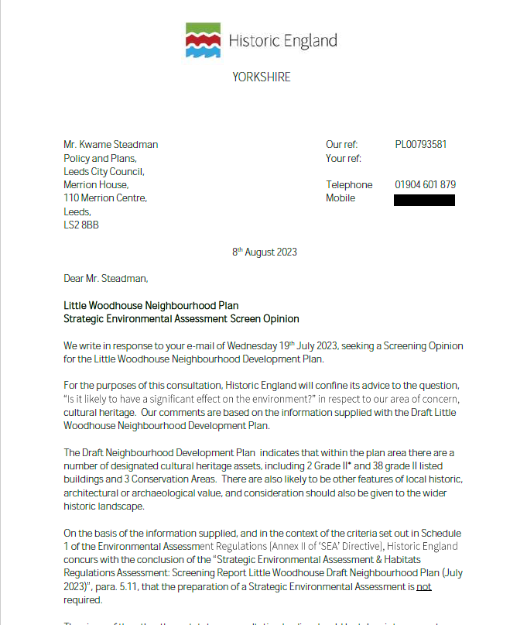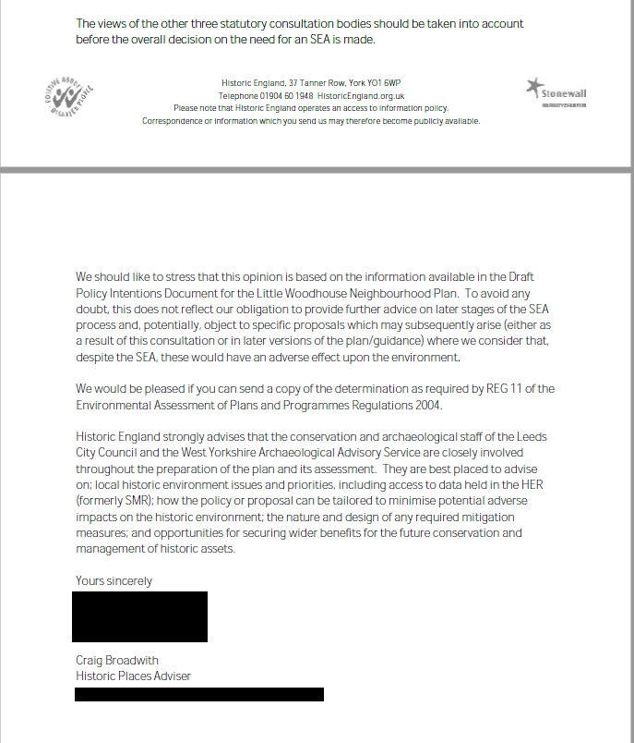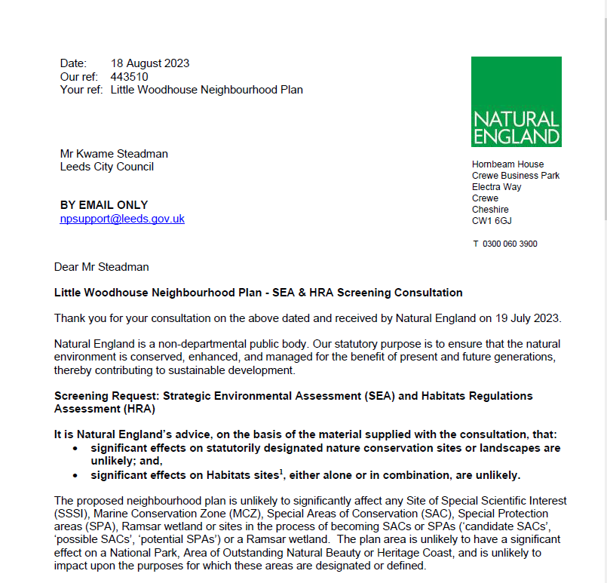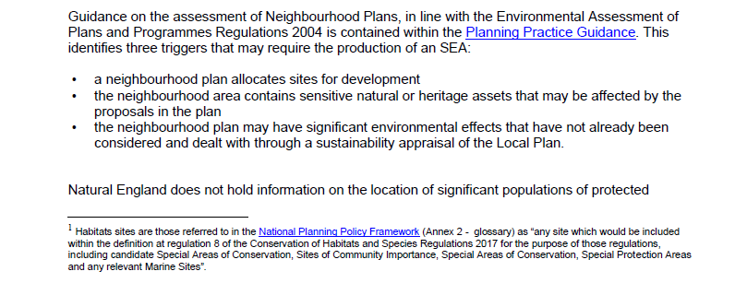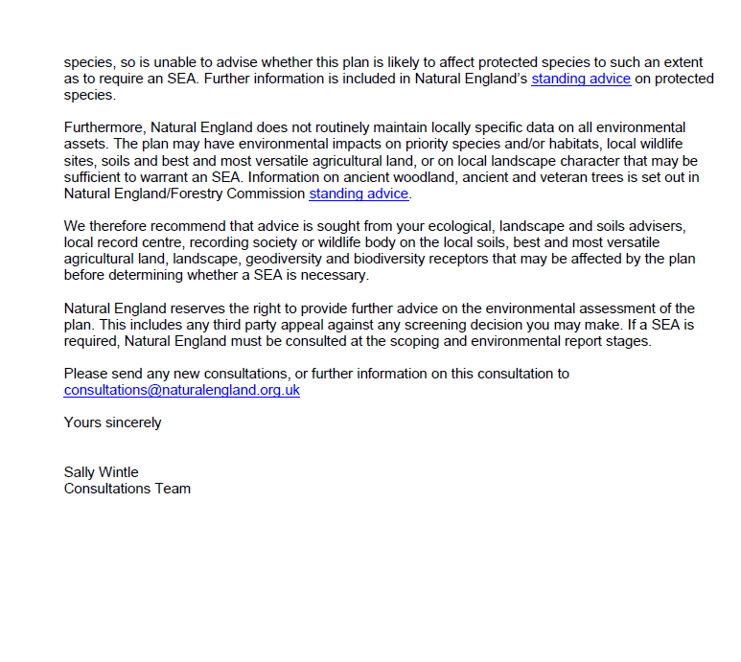

APPENDIX 2

Map showing SPAs and SACs in relation to the Little Woodhouse Neighbourhood Area
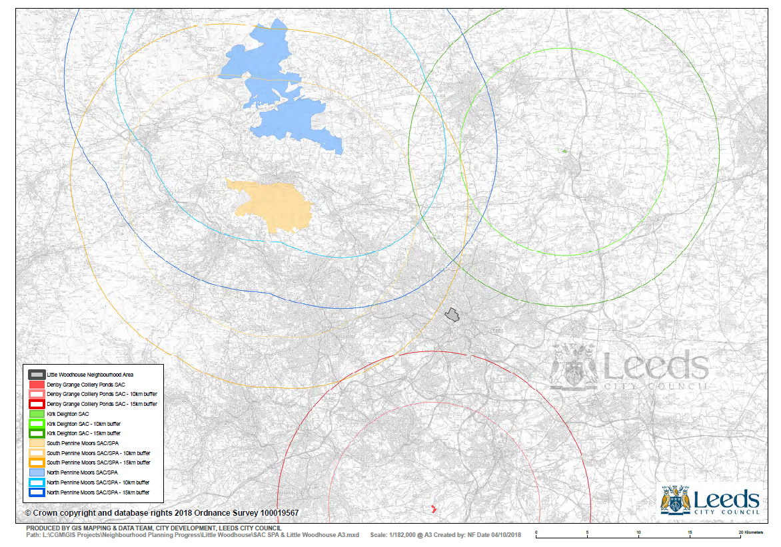

This establishes that the land-use plan may only be given effect if it will not adversely affect the integrity of a European site.
The making of the neighbourhood development plan does not breach the requirements of Chapter 8 of Part 6 of the Conservation of Habitats and Species Regulations 2017.

