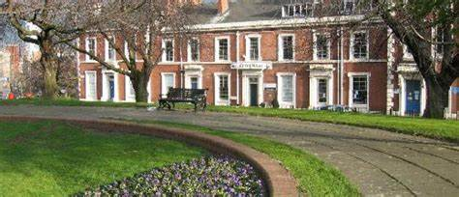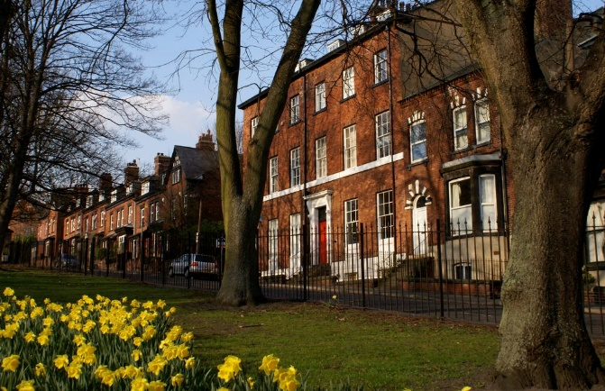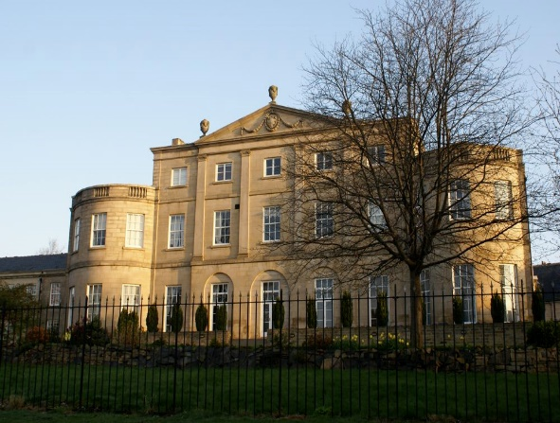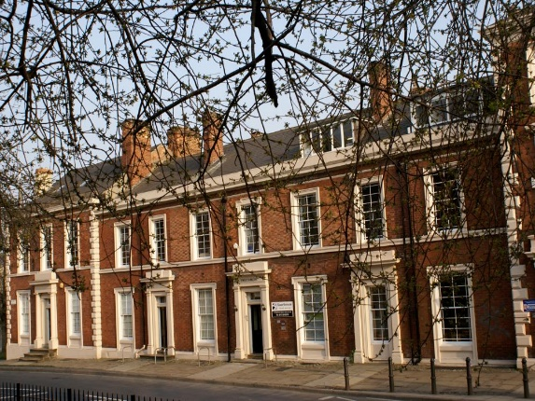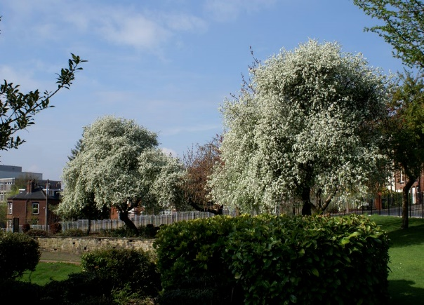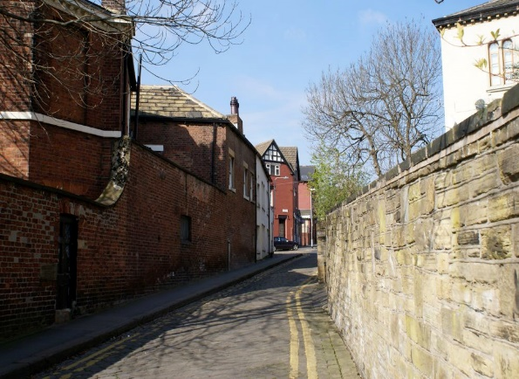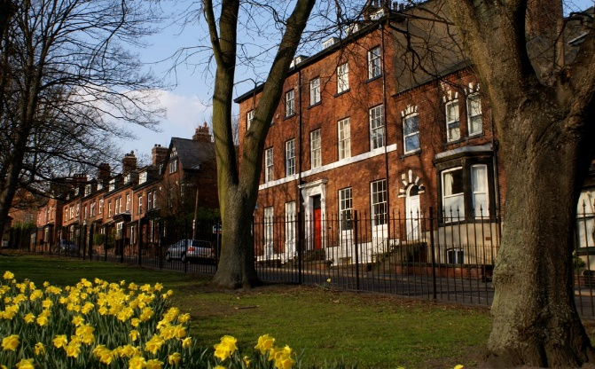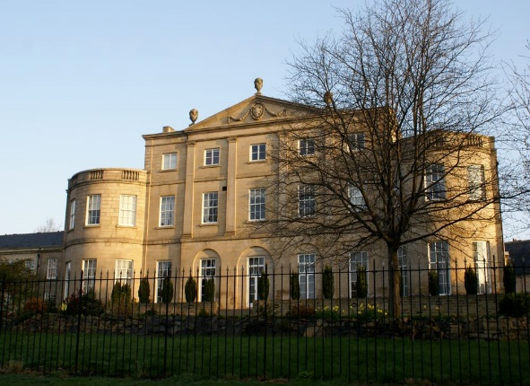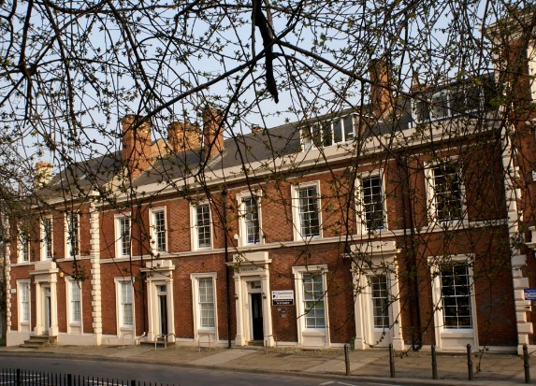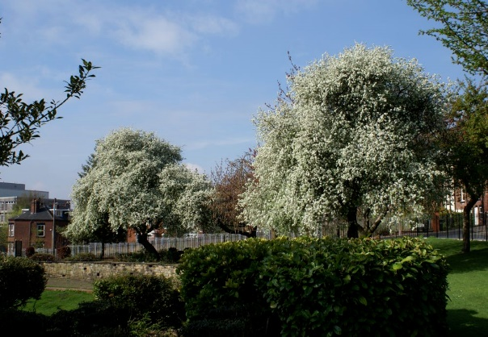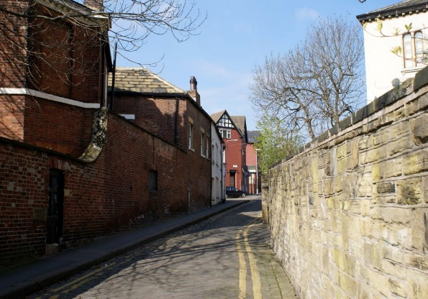
A Critical Analysis Report: “Reviewing the Contemporary Issues Surrounding Affordable Housing in the Little Woodhouse Area”
June 2023
Leeds Beckett University

Authored by: Jack Lever, Ellie-Mae Shelton, Vrutika Gohil and Munei Goba

Contents Page

Introduction……………………………………………………………………………….….…….2
Little Woodhouse Overview……………………………………………………………..……….3
Landlords - Competition for housing…………………………………………………….….…..4
Decline and Lack of Social Council Housing……………………………………………..……5
Space and Design of Houses not appropriate for the local demographic…………….……7
Economics – House Inflation……………………………………………………………….…...9
Conclusion…………………………………………………………………………………….…..9
Bibliography……………………………………………………………………………………...10

INTRODUCTION

The affordable housing market in the UK has been arguable in a state of crisis for a considerable period of time. Darren Baxter, Senior Policy Advisor at Joseph Rowntree Foundation, stated “The housing market is not working. In recent decades we have seen the rapid growth of the private rented sector alongside the decline in the proportion of households in social housing. Consequently, millions of people are stuck paying unaffordable rents, worried about being evicted by their landlord and have little opportunity to save” (Baxter, 2022). The housing charity, Shelter UK, continues to highlight that one category of affordable housing, social housing, is at significant risk with over one million households on waiting lists for social housing. There are now 1.4m million fewer social houses than there were in 1980 and in 2021, only 7,000 new social houses were built but 29,000 social homes were either demolished or sold (Shelter, 2022).
One issue around affordable housing is that there is no agreed definition for the sector and its sub sectors. However, the most commonly accepted definition of affordable housing is that set out in Annex 2 to the NPPF. The definition includes housing for rent or sale, for those people whose needs are not met by the market. This includes starter homes, discounted market sales and social rent. However, in 2020 the Affordable Housing Commission stated that government backed schemes like starter homes and discounted market sales and were still “clearly unaffordable to those on mid to lower incomes” (Affordable Housing Commission , 2020).

LITTLE WOODHOUSE OVERVIEW

Little Woodhouse Housing Makeup
As Pictured below (See Figure 1-3) Little Woodhouse, common with many areas of the Leeds City District, was predominantly used for the textiles industry, and this influenced many of the housing types that can be found in Little Woodhouse in the present day. By looking at the historic maps below, it allows a narrative to be told about the housing makeup, and how it has altered throughout the years.
Figure 3: Contemporary at scale 1: 200 (Digimap, 2023)
Figure 2: 1950s at scale 1:200 (Digimap, 2023)
Figure 1: 1930’s at scale 1:200 (Digimap, 2023)
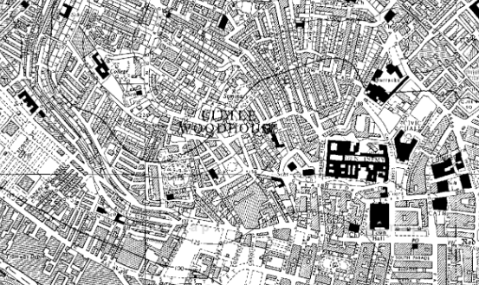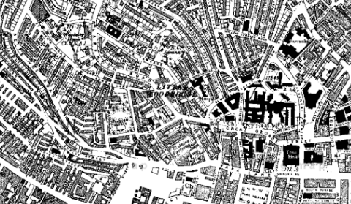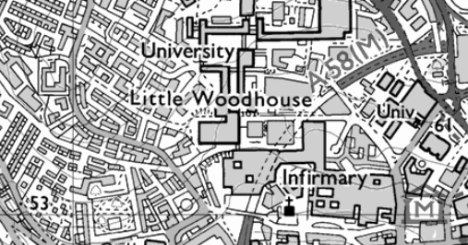

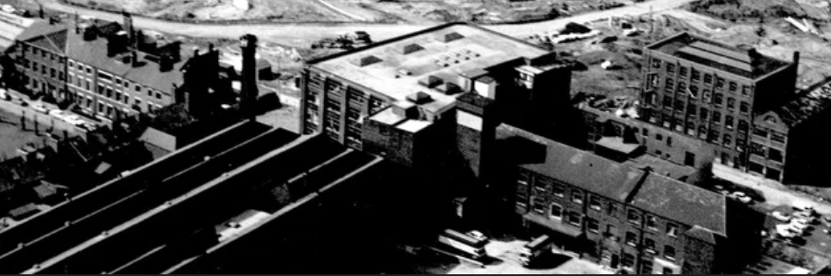
The images show that the housing density hasn’t altered dramatically since the 1930’s, with an abundance of Victorian purpose built terraces surrounding the textile mill, once used for the workers and their families. Little Woodhouse was home to premises of J. Hepworth and Son Ltd, clothes manufacturers, and as shown in figure 4 it was still functioning in 1965, as Leeds was just constructing the ring road. Today, many of the same terraces still exist, however these properties now have the purpose of being Houses of Multiple Occupation (HMO’s) typically used for Leeds’ Universities, with Little Woodhouse being in close proximity. These terraces make excellent temporary accommodation for students considering the size of the properties and the ability for landlords to convert them into many bedrooms with communal living spaces.
Figure 4: Textiles Mill (Yorkshire Evening Post, 2020)

Demographic of Little Woodhouse
Little Woodhouse sits within the Woodhouse and Hyde Park Ward, and has a growing population of students residing in the area. Combined, this area has 41.3% of the population (22,870) being students (Nomis, 2011) and this figure will only continue to grow as the biggest age bracket within the ward is 20 to 24 at 40.3%. Due to this the area is becoming increasingly attractive for investment by private landlords, considering the demand for student accommodation within close proximity to all of the Leeds Universities, and in 2011 the percentage of private rented properties within the ward sat at 47.5% (Nomis, 2011). This is due to private landlords buying the properties and converting them into HMO’s, and therefore taking them off the market for families, taking in an approximation of 4 times more rent which is calculated from each of the occupants within these properties. Will this This issue will be explained in further detail later on within this report.

Little Woodhouse Average Housing Prices
It is important to consider the affordability whilst looking at the housing market within the area of Little Woodhouse. In 2022, the overall average price for a property was £255,900 (Rightmove, 2023). “The majority of sales in LS3 during the last year were flats, selling for an average price of £121,500. Semi-detached properties sold for an average of £350,000, with terraced properties fetching £565,000. Overall, sold prices in LS3 over the last year were 45% up on the previous year and 8% up on the 2020 peak of £238,000” (Rightmove, 2023).

FIRST CONTEMPORARY ISSUE: Landlords - Competition for housing e.g., HMO and PBSA – LCC

Leeds, like other university cities, has been influenced by a large student population in terms of its economic, social, and cultural characteristics. The student population at the two main universities in Leeds in 2020/21 was 60,555 (HESA, 2023). The expansion of admissions to universities over the last 10-15 years has resulted in significant demands on the supply of student accommodation. Whilst the universities in Leeds have invested in new Purpose-Built Student Accommodation (PBSA), there remains a significant majority of students who in year 2 & 3 of their studies want to live in areas where there is a high percentage of other students living and where there is a high availability of Houses of Multi Occupation (HMO’s) to rent. Darren Smith defined the term of “studentification” for such areas and provided the definition of studentification as “contradictory, social economic and physical changes resulting from the influx of students within the privately rented accommodation in particular neighbourhoods” (Smith, 2002).

In the Little Woodhouse area in Leeds the proportion of students living in the area has increased from 48% in 2007 to 76% in 2016, an increase of 55%. This high proportion of students is reflected in the position that 90% of the population in the area live in rented accommodation, compared with a Leeds average of 40% (D Piper, 2023).
The rise of the “Buy to Let” (BTL) private investor market emerged in the mid 1990’s following the housing crash in the late 1980’s, with mortgage lenders offering new BTL products into a market where house prices started to rise significantly. The student BTL market based on private investors/landlords purchasing family homes in areas, such as Little Woodhouse in Leeds, and converting them into student HMO properties was an attractive market for investors. This attractiveness has continued and reflects a maintained growth in student numbers, strong desire by many students to live in HMO’s in communities with their friends despite increase in PBSA. The student BTL market also has the advantage to investors that it is based on the model of a 12 month short term tenancy agreements, which means that landlords aren’t significantly exposed to the risk of undesirable tenants and the model also ensures that rents are “guaranteed”, often by the parents of the students. In 2020 the average rental income from a student BTL HMO in Leeds was £19,052, with an average return of investment yield of 7.62% (Paragon , 2022). This level of return, in addition to capital growth on the property, has been seen by investors as an attractive market return, relative to the risks.

The impact on the availability of affordable housing, in particular families, of the student BTL market in an area like Little Woodhouse has been considerable. If a 3 to 4 bed house in the area can attractive an annual rent of £19,052 from students, then there is no realistic chance that a working family who want to live in the area can afford to pay that level of rent. Against these specific house market conditions in Little Woodhouse, the affordability of housing is an acute issue.

Leeds City Council introduced an Article 4 Directive in areas with high student population, including Little Woodhouse, in 2012. The aim of introducing an Article 4 Directive was to control the further increase of student HMO’s in an area and therefore limit the further impacts of housing affordability as well as limit the other undesirable impacts of studentification on an area e.g. anti-social behaviour, litter, noise and drug culture. Article 4 Directives are a rather blunt planning control tool, with loopholes which can be exploited, and are not retrospective i.e. they do not reduce the number of student HMOs from the level that existed prior to 2012. In an area like Little Woodhouse with an already very high student population living in HMO’s, the impact of Article 4 Directive will not have been that significant. There is a rationale, the introduction of Article 4 Directives has actually made the issue of affordability worse for non-students. As when existing student HMO’s are sold, they attract very high market values from investors, as the Article 4 Directive has had the result of capping any new houses being converted into a student HMO in the area.
In conclusion, the student BTL market in Little Woodhouse is a material contemporary issue which impacts the affordability of houses in the area as well as the social, environmental and physical characteristics of the community. Whilst an Article 4 Directive was introduced in 2012, it doesn’t provide a realistic mechanism to improve the affordability of housing in the area. The proposed Little Woodhouse Neighbourhood Plan, with more specific planning policy controls and a more overall embracing approach, should have the potential to strike a better balance in the community between students and non-students.

SECOND CONTEMPORARY ISSUE: Decline and Lack of social council housing in area
The lack of social housing in Little Woodhouse, as in many areas across the United Kingdom, is a significant issue that affects many people. The high demand for social housing in the area means that there is often a long waiting list for properties, and some people may struggle to find suitable affordable housing.

There are a few reasons for the lack of social housing in Little Woodhouse and other areas. One reason is that the demand for housing often outstrips the supply, leading to a shortage of affordable homes. Additionally, government policies over the years have focused more on encouraging private sector housing development rather than investing in social housing.
However, the local authorities are aware of the shortage of social housing and are taking steps to address it. Leeds City Council has developed plans to build new social and affordable housing in the area, and they work closely with housing associations to provide more affordable homes for people in need. They also encourage private developers to include social housing in their developments, and they provide financial assistance to help people access private rented accommodation.
Despite these efforts, the shortage of social housing in Little Woodhouse and other areas is likely to remain a significant issue for the foreseeable future.

There has been a decline in social housing across the United Kingdom over the past few decades. In the 1970s, social housing accounted for around one-third of all homes in the country, but by the mid-2010s, that figure had fallen to around one-fifth.
One of the main reasons for the decline in social housing is the government's shift towards promoting home ownership and encouraging private sector housing development. Since the 1980s, the government has introduced various policies that have made it easier for people to buy their own homes, such as the Right to Buy scheme, which allowed council tenants to purchase their homes at a discount.

While these policies have helped many people become homeowners, they have also led to a reduction in the number of homes available for social housing. When council homes are sold under the Right to Buy scheme, they are often not replaced, which has led to a decrease in the overall number of social homes available.
Another reason for the decline in social housing is the lack of investment in building new social homes by successive governments. There has been a chronic shortage of affordable housing in the UK for many years, and the lack of investment in building new social homes has contributed to this problem.

Additionally, some people argue that the decline in social housing is a result of wider social and economic changes, such as the rise of the gig economy and the decline in secure, well-paid jobs. These changes have led to an increase in poverty and inequality, which has made it more difficult for people to access decent affordable housing.
Overall, the decline in social housing is a complex issue with multiple causes. While there have been some efforts to address the problem, such as the government's recent commitment to build more affordable homes, more needs to be done to ensure that everyone has access to decent, affordable housing.

Housing in Little Woodhouse, Leeds, has gone through significant changes over the years. The area has a rich history of Victorian terraced houses and early 20th-century back-to-back housing, which were originally built for the city's growing working-class population. However, many of these houses have since been renovated or redeveloped, and there has been a shift towards more modern housing developments in recent years.
During the 1960s and 1970s, the city council built several tower blocks in Little Woodhouse, such as the Marlborough Towers and Lyndhurst Flats, to provide high-density housing for the city's growing population. However, by the 1980s, these tower blocks were seen as problematic due to issues with antisocial behaviour, poor maintenance, and the quality of living conditions. As a result, many of these tower blocks were demolished, and new low-rise social housing developments were built in their place.

In recent years, there has been a focus on the regeneration of the area, with new housing developments and improvements to existing housing stock. For example, the Little Woodhouse Hall development is a recent addition to the area, comprising a mix of affordable and private housing, built on the site of the former Hall Lane Industrial Estate.
However, the demand for affordable housing in the area remains high, and there is a shortage of social housing. As a result, the local authorities are working to build more affordable homes and to encourage private developers to include social housing in their developments. Despite these efforts, the issue of affordable housing remains a significant challenge for Little Woodhouse and other areas in Leeds.

To address the issue of gentrification and displacement in Little Woodhouse and other areas, there have been calls for a more balanced approach to housing development, one that prioritizes the needs of residents and ensures that affordable housing is available. The local authorities in Leeds have implemented various policies and initiatives to address this issue, such as the inclusion of affordable housing in new developments and the provision of financial assistance to help residents access affordable housing.

THIRD CONTEMPORARY ISSUE: Space and Design of houses not appropriate for the local demographic

Based on current evidence from significant research, the space and design of Little Woodhouse is inappropriate for the local demography due to an imbalance in the mix of housing which has been perpetrated by the establishment of Leeds University in the neighbourhood (Little Woodhouse Community Association, 2023; Miladinovic, 2021). The Little Woodhouse Neighbourhood Forum as early as 2016 did an assessment of the housing mix—family housing included—and the locations of Purpose-Built Student Accommodation (PBSA) in Little Woodhouse. According to the National Planning Policy Framework “Neighbourhood plans can shape, direct and help to deliver sustainable development by influencing local planning decisions as part of the statutory development plan” (Ministry of Housing Communities and Local Government, 2021:10). Also, the Localism Act 2011 provides for local forums, community, or parish councils to develop a local plan which is subject to approval through an examination process or through a referendum (Stephens in UK Housing Review, 2018). Considering this, Little Woodhouse Community Association has a Neighbourhood Design Statement, with the aim to improve the neighbourhood for all who live and work there (Little Woodhouse Community Association, 2023). The Community Association has an agenda to meet the housing aspirations of all residents, by providing an even mix of housing stock, to meet the needs of all types of households, such as, families with children, younger and older people, and housing cooperative ventures.

The establishment of a university in the Little Woodhouse local area has led to an unprecedented increase in the number of students desiring accommodation that is as close to the university as possible such that the proportion of students in Little Woodhouse has increased from 48% in 2007 to 76% in 2016 – an increase of 55% (Office of National Statistics). According to the 2011 Census over 50% of Little Woodhouse population is aged 15-24 years old compared to 12% for the rest of Leeds. The 2001 Census placed the population of Little London and Woodhouse at 15,225 which rose to 31,076 in 2021 with 13,252 of them being aged 20-29 years old (Office for National Statistics, 2023). With some parts of Little Woodhouse having the student population accounting for almost 90% of total population inversely the number of 0–4-year-old is decreasing as similarly is the 60–84-year-old population group. According to the Office for National Statistics (2011) the demographic age 15-29 years population is highest in Leeds and Little London compared to other parts of England. This evidence suggests that the number of families living in Little Woodhouse is shrinking because due to housing market forces all residential accommodation is being pushed by profit motivation into student accommodation, whether its single person or multi-person. This is supported by the statistic that approximately 90% of all housing in Little Woodhouse is now rented compared to an average of 40% elsewhere in Leeds.

Space and Design: What is on the Ground.

While multi-person households account for just 2% of all households in the rest of Leeds in Little Woodhouse alone, they account for 16%. Conversely families with dependent children account for 13% of households in Little Woodhouse compared to 27% for the rest of Leeds. The family housing tenure in Little Woodhouse is shrinking and under threat from the increasing purpose-built student accommodation and multiple occupation housing. This threatens the rich heritage of the neighbourhood buildings, green spaces, and its streets. The high concentration of students has implications such as noise and environmental pollution and issues of parking space. The Little Woodhouse Neighbourhood Plan (2023) contends that “The regular turnover of tenants … can lead to a disconnection with Little Woodhouse as a place, and creates problems with litter, occasionally noise and other nuisances arising from a perception of the area as easy prey for petty crime and graffiti” (5). The lives and welfare of long-term residents have been affected. The current tenure mix threatens the continued existence of the community as it can no longer sustain different sized households and different age groups. This is contrary to one of the pillars of the Leeds Housing Strategy 2022-27 that “In 2030 Leeds will have an economy that works for everyone, where [they can] work to tackle poverty and ensure that the benefits of economic growth are distributed fairly across the city, creating opportunities for all” (Leeds City Council, 2022:7). Opportunities for those who would wish to raise families in Little Woodhouse have become limited as most family housing has been converted to student accommodation (Little Woodhouse Neighbourhood Plan, 2023).

Space and Design: What needs to be done.

The Leeds Housing Strategy 2022-27 has a vision to meet “the city’s housing needs and [provide] high quality affordable homes in thriving and inclusive communities, with appropriate support for those who need it” (Leeds City Council, 2022). Bringing to par household growth in Leeds with the preferences expressed in the Strategic Housing Market Assessment 2017 (SHMA) survey therefore suggests the following mix of dwelling sizes that should be aimed for: 22.5% 1-2 bed, 29.4% 3+ bed and 14.4% 4 beds across Leeds on average. The Ministry of Housing Communities and Local Government (2021) has an agenda to achieve what it calls sustainable communities achievable through the three objectives economic, social, and environmental. The National Planning Policy Framework supports the neighbourhood plans and that their identified housing allocations should be a priority. The report has concluded that the discrepancies in housing mix in Little Woodhouse are a result of the conversion of family housing to multi-occupation student accommodation which has resulted in significant reductions in families with children in the neighbourhood due to challenges in securing housing suitable for families such as three to four bedroomed housing. The report has suggested implementation of the Strategic Housing Market Assessment 2017 recommendations to address the problems with housing mix in Little Woodhouse.

FOURTH CONTEMPORARY ISSUE: Economics – house inflation – pushing out locals who can no longer afford to live in the area
Like many urban areas, Little Woodhouse in Leeds has experienced housing inflation in recent years, driven by factors such as increasing demand for housing, limited supply, and changes in the local economy.

One factor contributing to housing inflation in Little Woodhouse is the increasing popularity of urban living, which has led to a growing demand for housing in city centres. This demand has put upward pressure on property prices, making it harder for local residents to afford to buy or rent homes in the area. Additionally, changes in the local economy can also impact housing inflation. For example, if there is an increase in high-paying jobs in the area, this can lead to an influx of affluent individuals, which can drive up property prices. Conversely, if there is a decline in the local economy, this can lead to a decrease in demand for housing, which can result in lower property prices.

Another factor contributing to housing inflation in Little Woodhouse is the limited supply of housing in the area. With a growing population and limited land available for development, there is often fierce competition for housing, which can drive up property prices.
To address the issue of housing inflation, the local authorities in Leeds have implemented various policies and initiatives to increase the supply of affordable housing in the area. For example, the council has invested in new social housing developments and has introduced policies to encourage developers to include affordable housing in new developments. It is important to note that housing inflation is a complex issue, and there is no one-size-fits-all solution. However, efforts to increase the supply of affordable housing and address the root causes of housing inflation can help to ensure that residents are able to continue to afford to live in Little Woodhouse and other urban areas.

CONCLUSION
In conclusion, it is clear that the Little Woodhouse area is consistent with the national housing outlook as they both face growing issues. Both the country and Little Woodhouse face increasing pressures to accommodate growing populations within areas, which have a decreasing housing stock. This has evidently increased house prices in Little Woodhouse contributing to cyclical impact and resulting in a clear lack of both affordable housing and social housing. However, the process of studentification within Little Woodhouse has magnified the issue of affordable housing within the area. The increase in HMO properties as a result of investors/landlords purchasing family homes in Little Woodhouse and converting them is the most significant issue contributing to the lack of affordable housing in the area.
Looking to the future, the Article 4 directive must play a significant role in limiting the number of new HMO properties as this will only decrease the available housing stock and increase house prices further. Any new Neighbourhood Plan for Little Woodhouse should seek to prioritise creating new areas or converting existing areas for affordable housing and social housing.

BIBLIOGRAPHY
Digimaps (2023). Historic Roam. Online. <<Available at: https://digimap.edina.ac.uk/roam/map/os?unifiedClient=true> Accessed 20/05/23>
Little Woodhouse Community Association (2023) Little Woodhouse Neighbourhood Design Statement: Design Guidance for Residence & Developers

Miladinovic, A. (2021) Re-designation of Little Woodhouse Neighbourhood Forum, Leeds City Council.

Ministry of Housing Communities & Local Government (2021) National Planning Policy Framework, UK, London: Ministry of Housing Communities & Local Government.

Nomis (2011). Hyde Park and Woodhouse Ward (as of 2011) Local Area Report. Online. <<Available at: https://www.nomisweb.co.uk/reports/localarea?compare=E05001429#section_8_3> Accessed 20/05/23>

Office for National Statistics (2016) Census 2011

Office for National Statistics (2023) Little London & Woodhouse, Ward in Yorkshire, and The Humber,

Stephens, M. (2018) ‘Planning Frameworks and housing delivery’. In UK Housing Review 2018, Chartered Institute of Housing, pp. 21-28.

Affordable Housing Commission . (2020). Making Housing Affordable Again . London Affordable Housing Commission.

Baxter, D. (2022). Reform of the Housing Market . York : JRF.

D Piper. (2023). Little Woodhouse Neighbouhood Plan Presentation. Leeds: Piper.

HESA. (2023, March 13). Who's studying in HE? Retrieved from Higher Education Statictics Agency: https://www.hesa.ac.uk/data-and-analysis/students/whos-in-he#provider

HESSA. (2023, March 23). Income of HE Poviders. Retrieved from Higher Education

Statistics Agency: https://www.hesa.ac.uk/data-and-analysis/finances/income

Paragon . (2022). Studying Student Buy to Let . London : Paragon.

Shelter. (2022). Social Housing Deficit . London: Shelter.

Yorkshire Evening Post (2020) Fascinating photos of Leeds city centre during the 1960s. Online. <<Available at: https://www.yorkshireeveningpost.co.uk/heritage-and-retro/retro/fascinating-photos-of-leeds-city-centre-during-the-1960s-2908859> Accessed 20/05/23>

